

SOCIAL MEDIA TOOLKIT

We are joining you as you prepare for a successful and productive school year!
As an I’m Healthy Today Schools client, or potential client, we wanted to provide you with some resources specifically for your school’s website or social media pages.
Included in this Toolkit you will find:
- Imagery
- Hashtags
- Sample captions
- Suggested posting times
- Campaign tips
Please feel free to use as much of the content provided as you would like.

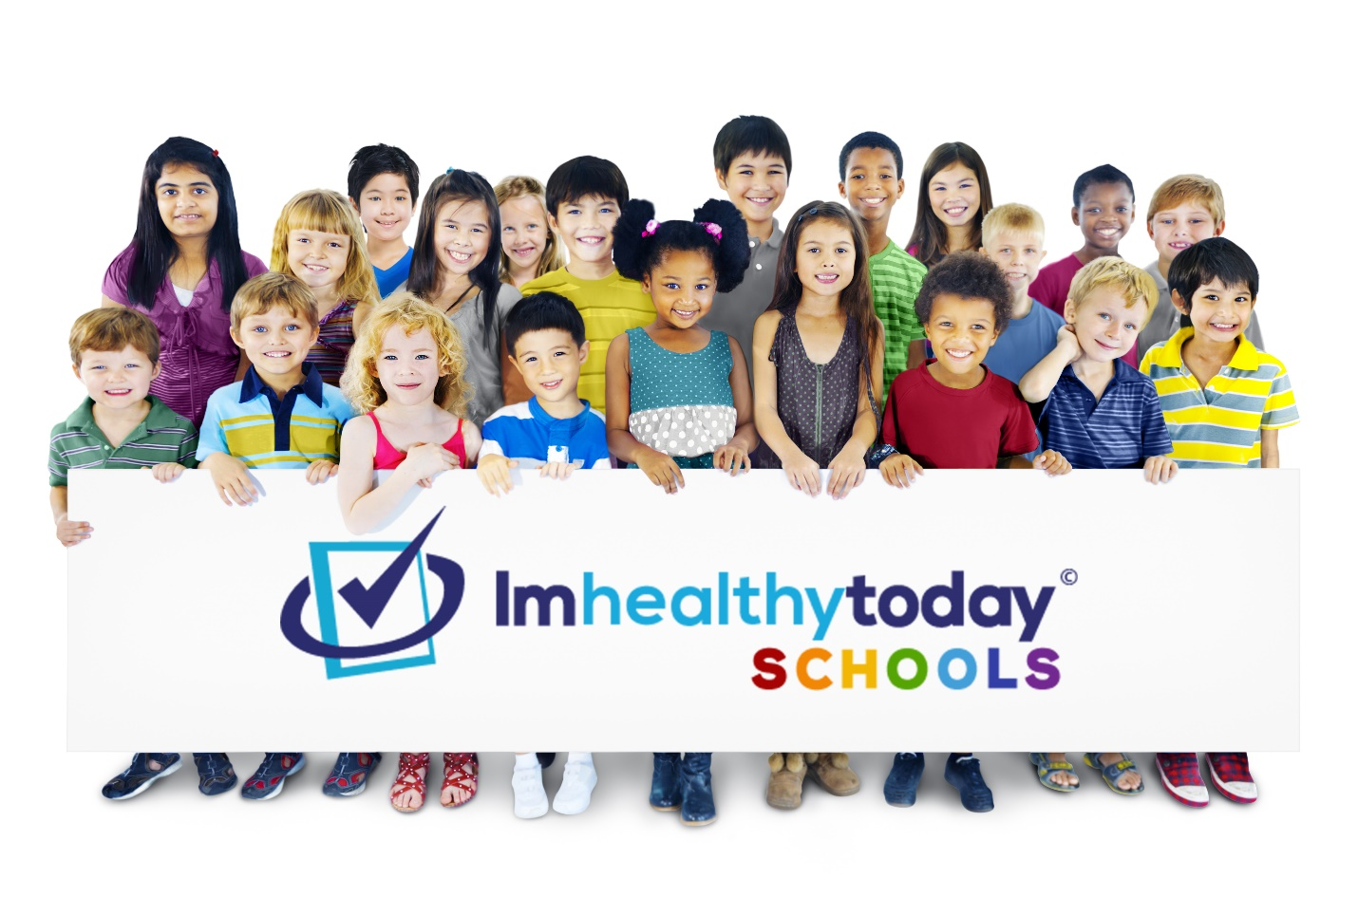

Imagery
The following images can be used to add a visual flair to your campaigns and spread the word about how your school is planning to reopen safely. Feel free to customize and add your school’s logo, we encourage you to get creative!

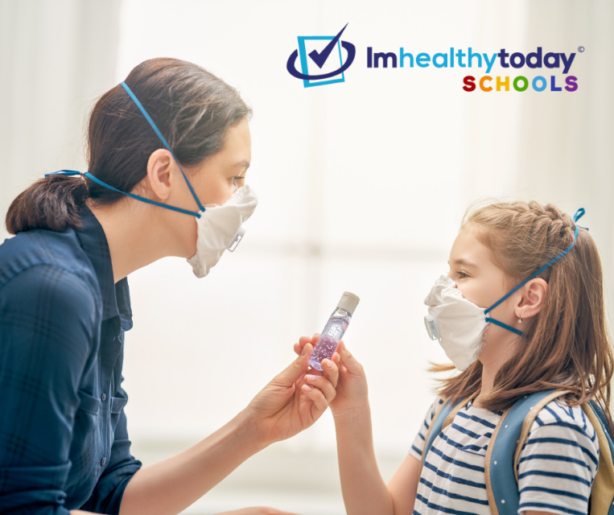
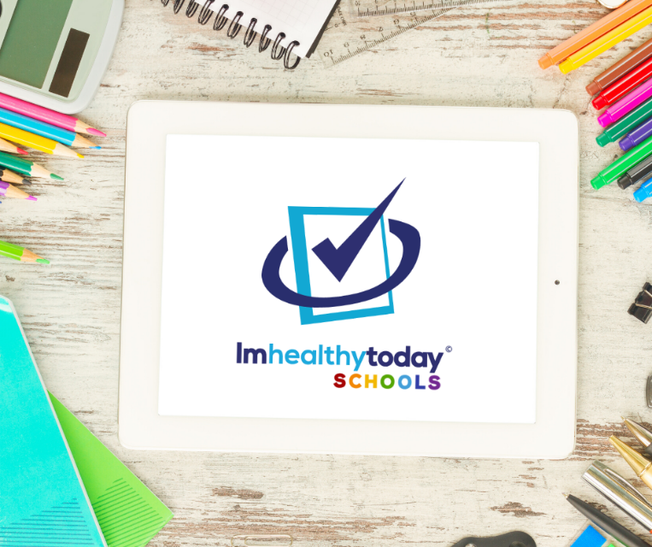


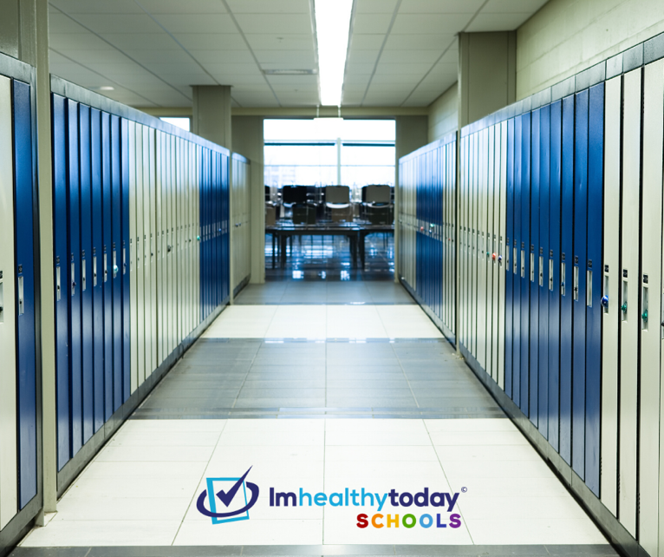
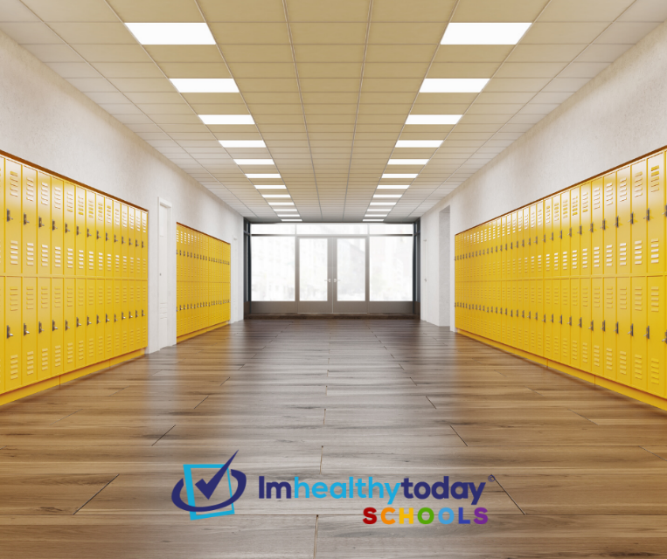
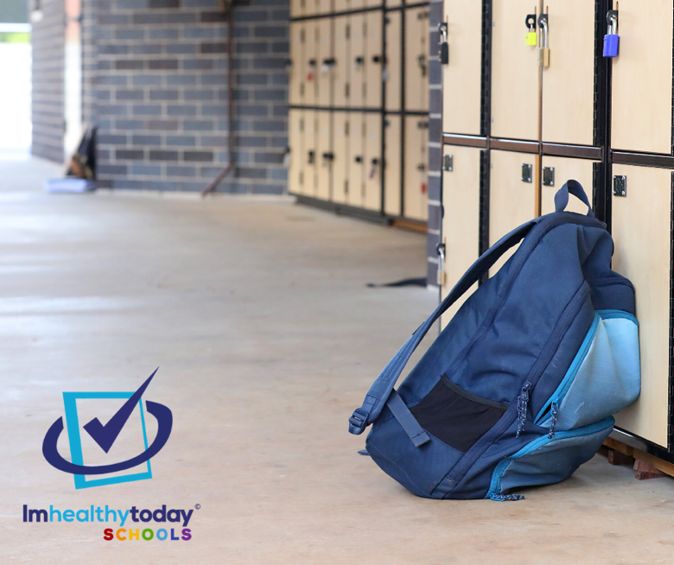
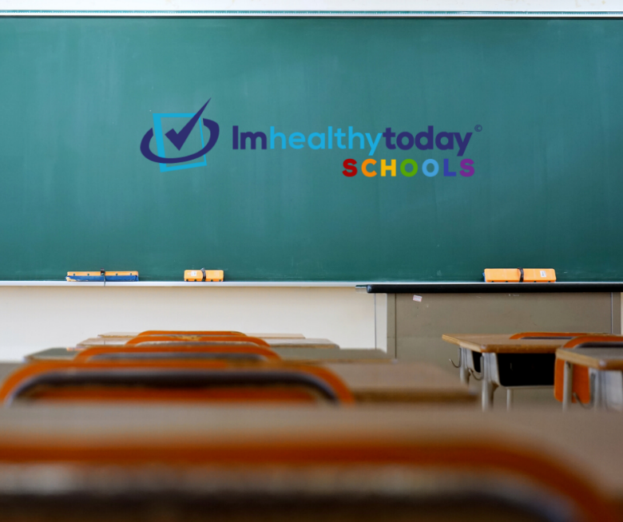
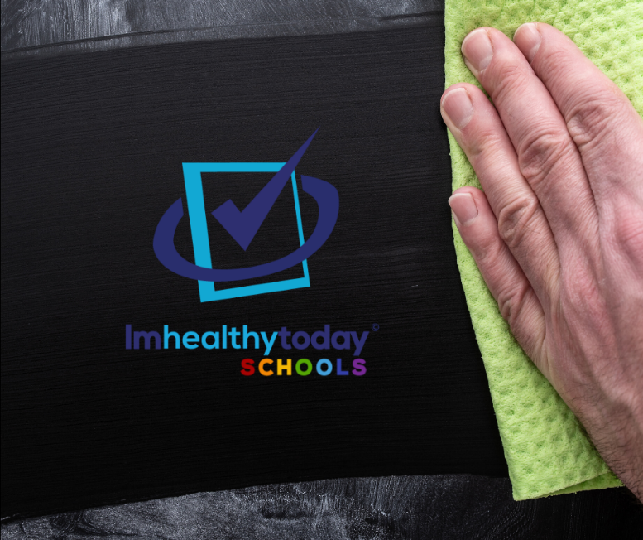
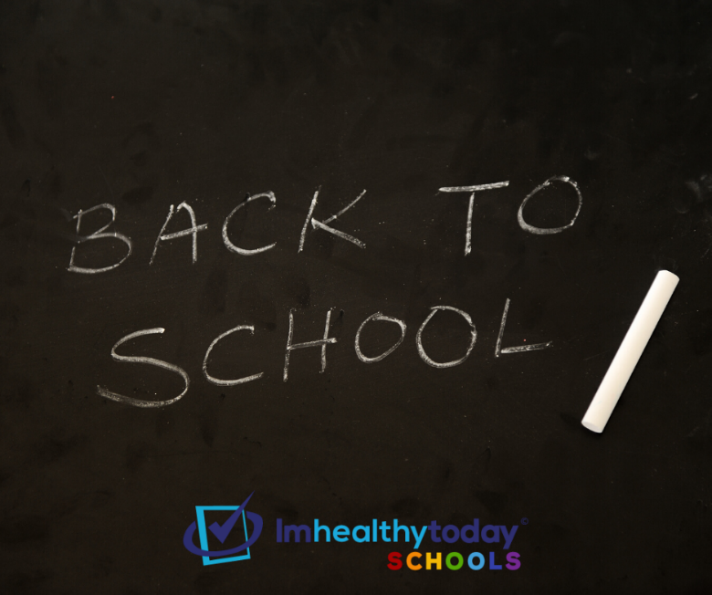

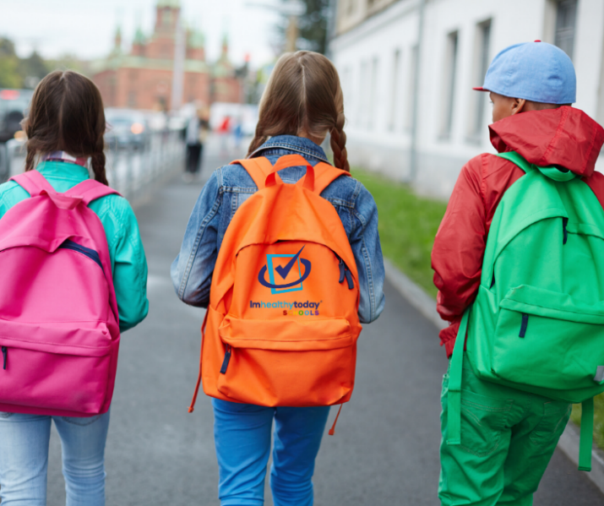
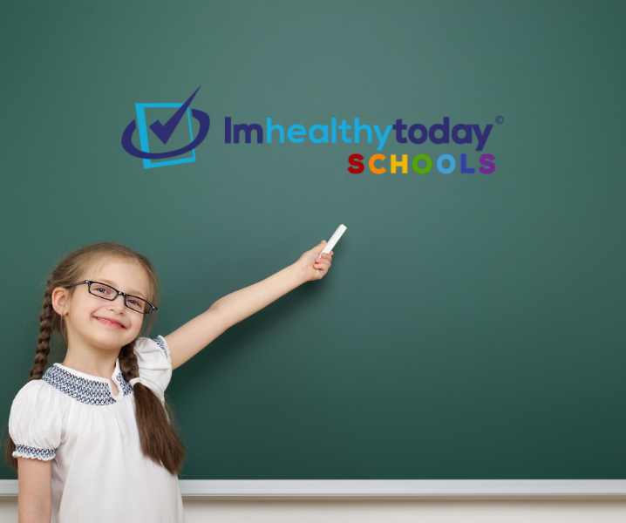
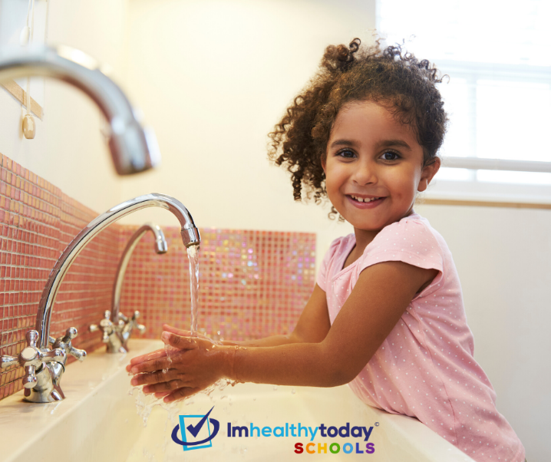
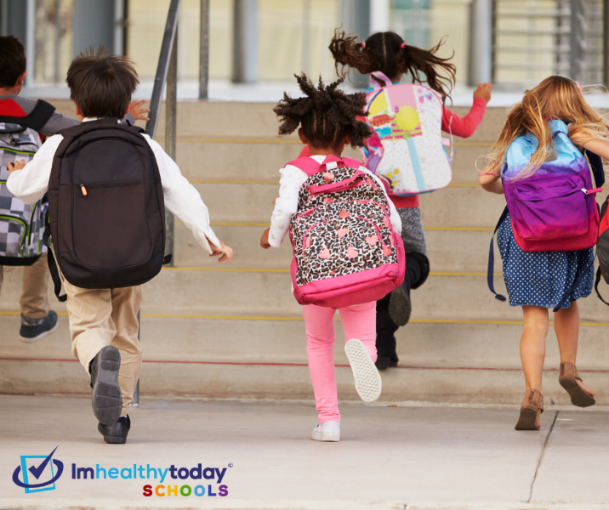
Hashtags
Hashtags are a great way to drive specific audiences to your campaigns. They are used to categorize and find conversations around a particular topic or trend. Use these hashtags in your social media captions to drive as much engagement as possible.
#BackToSchoolSafely
#SafeSchools
#SafetyForAll
#COVIDResponse
#ImHealthyTodaySchools
Sample Captions
- If you are a parent and are interested in learning more about this program, please contact [School Administrator/Principal, contact information].
- To learn more about this program and what [Your School Name] is doing to reopen safely, please contact [contact information].
- Our program begins where others end! [Your School Name] has invested in a turnkey solution to keep students, staff, and faculty safe.
- We are excited to announce a new program for the start of the school year! To learn more, please contact [contact information].
- [Your School Name] is implementing a comprehensive school safety program designed and managed by doctors so we can return to school confidently!

Posting Times
The best time to post on social media varies depending on your audience, but the most popular times according to social network experts are:

Facebook
11-11:15 AM; 8-9 PM

Instagram
10-11 AM; 2-3 PM

Twitter
10 AM - 12 PM; 5-6 PM

LinkedIn
8AM, 12 PM, 5-6 PM
Campaign Tips
- Create content that portrays how your mission is something people want to support: Educate others on your cause area and what your school is doing to be a safe place to learn and grow despite the pandemic.
- Brand your school’s website and social media to gain the support of the community and raise awareness.
- Remember to share on your personal social media and not just the school’s account.
- Encourage your faculty, staff, students, and parents to share the posts on their social media accounts also.
- Organize a chat (Facebook Live or previously recorded) about your school’s mission with your team members.
- Discuss how your school has responded to the pandemic and how it has impacted your work.

